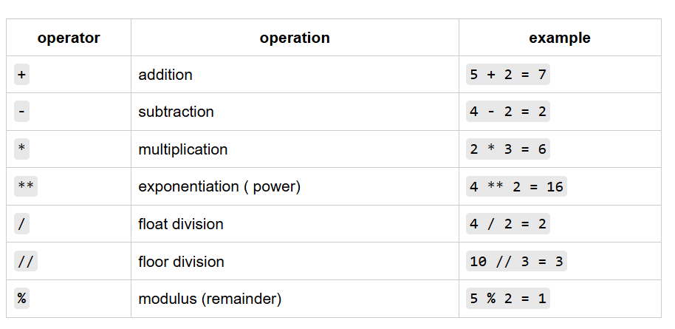

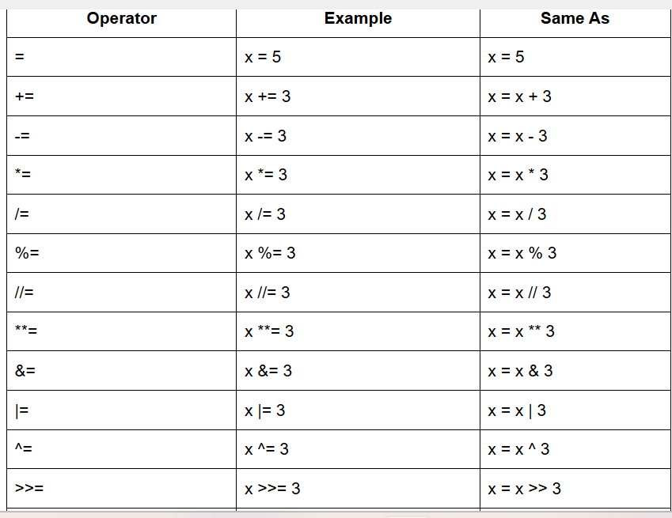

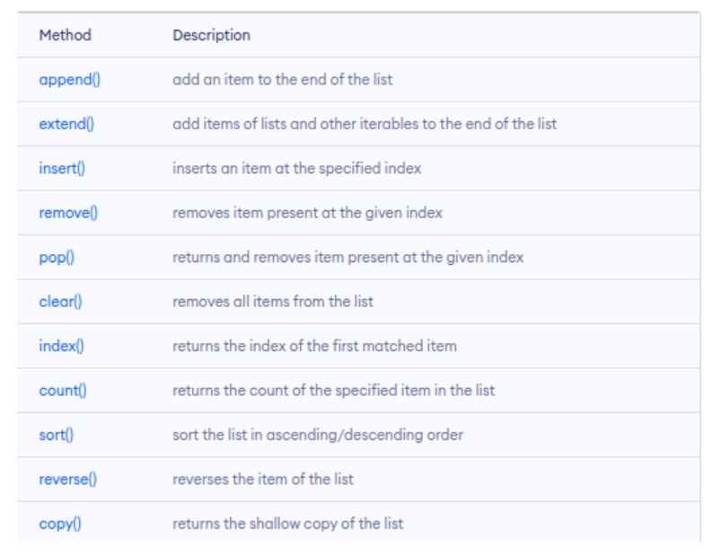

opened_file = open('AppleStore.csv') #Open a CSV file

from csv import reader #Import reader

read_file = reader(opened_file) #Read in the opened file using the reader() function

apps_data = list(read_file) #Transform the read-in file to a list of lists using the list() function

len() function #Determine the length of Variable

print(type(apps_data)) #Prints the variable type of apps_data

float(rating) #Changes variable type to float

apps_data=apps_data[1:] #Saves data from the index 1 to last

empty_list = []

empty_list.append(12) #add (or **append**) values to a list

sum() function #to add all the ratings

